**Software Installations**

**Installing Python**

Download: <https://www.python.org/ftp/python/3.12.0/python-3.12.0-amd64.exe> in any directory of your choice.

Double click on the downloaded file to install. Please follow the steps below.

1. Check the checkbox to select ‘Add python.exe to PATH’.
2. Select ‘Customize installation’. Click Next.

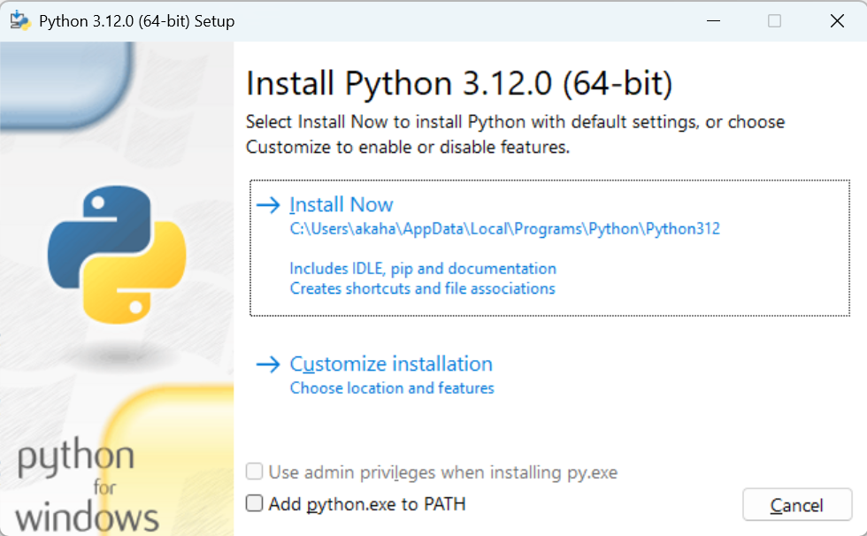

1. In ‘Customize install location’,
   1. Check the checkbox ‘Add Python to environment variables’
   2. Type the path manually: Either c:\python312 or d:\python312 or e:\python312 depending on what drive exists in your disk.

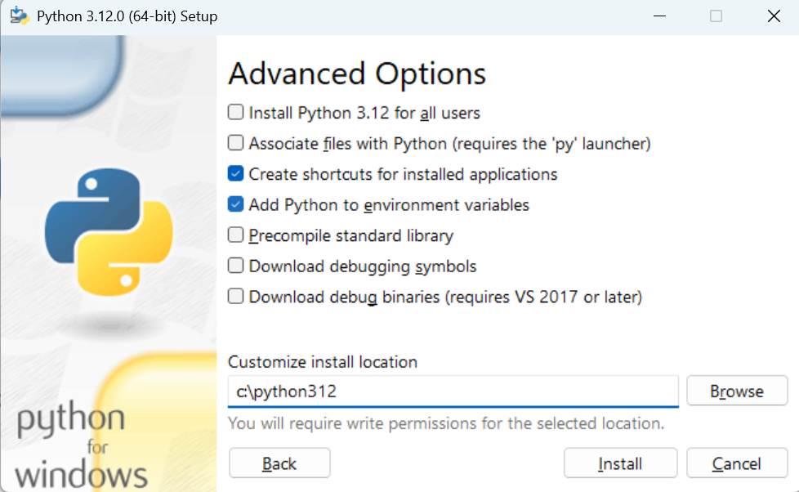

1. Proceed with the remaining steps

To verify if Python is successfully installed:

1. Open a new terminal: Click on Windows start button -> In Search, type: cmd. (Note: You must open a new terminal. If you try this in a terminal that was already open, it will not work.)

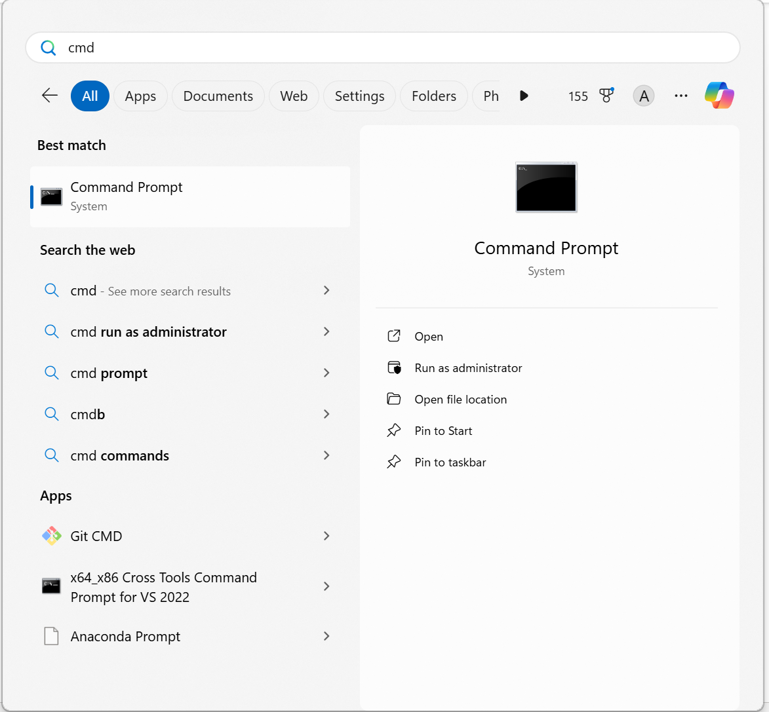

1. Type python --version. If it shows the Python version, Python is successfully installed. Do not worry if it shows Python 3.12.0 or some other number. It is ok. (Because I have installed Python 3.12.10, so my machine’s version number could be different).

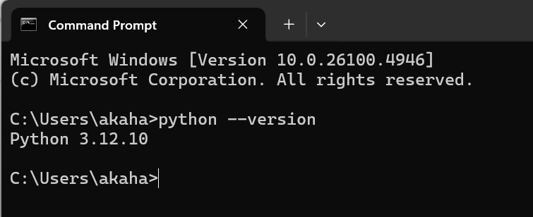

**Installing Visual Studio Code**

Go to <https://code.visualstudio.com/download>

Under Windows, click on ‘User Installer’ X64, Arm64

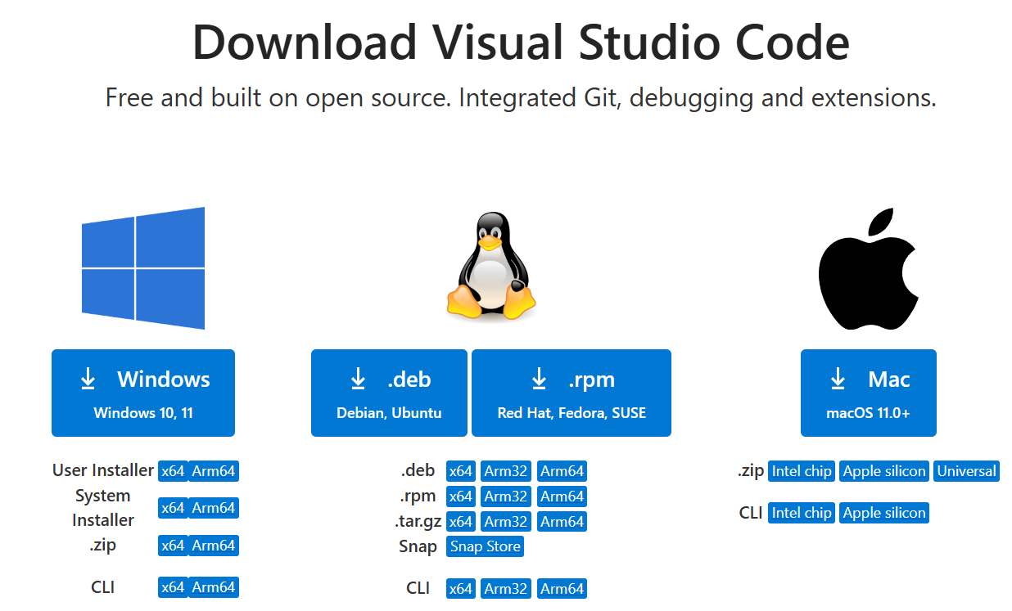

Double click on the installer file to install.

After the installation is complete, create a new directory on your machine: Either c:\code, d:\code, e:\code, depending on the available drive.

To run VS code, Windows start button -> Search: code and click on Open.

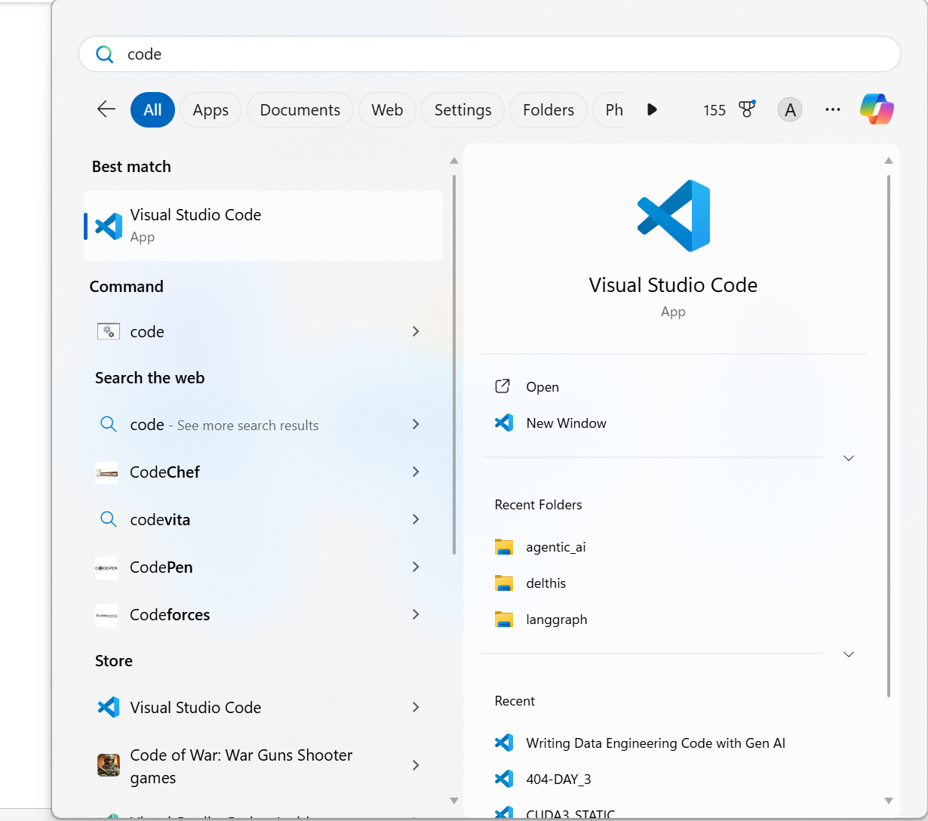

It will start VS Code.

After some initial messages: Click File -> Open Folder.

Select the directory created earlier (either c:\code, d:\code, e:\code).

**Installing packages**

All important packages are listed in the file **requirements.txt**

On the terminal, run the command **pip install -r requirements.txt**